Design Assignment using an App Prototyping tool

Fall 2024

You are to break up into groups of two or three individuals and design an app using the Marvel prototyping tool. You can build anything you want; it just has to have **at least six** screens.

This is an example of an app that offers course tutorials.

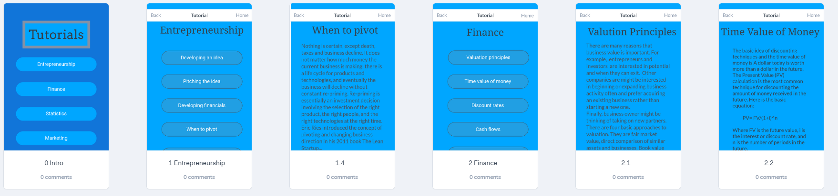

**Steps**

* The groups will design an app using the Marvel prototyping tool.
* Go here <https://marvelapp.com/signup/> and signup.
* Also go here for help: <https://help.marvelapp.com/hc/en-us>
* Go here read and watch videos: <https://help.marvelapp.com/hc/en-us/articles/360002536038-How-to-create-a-prototype>
* Create the prototype using Chrome, Firefox or Safari browser on the Marvel Website using the built-in tool.

Examples:

* <https://marvelapp.com/prototype/184276f9>
* <https://marvelapp.com/prototype/6557if6>
* <https://marvelapp.com/prototype/ifi2fbe>
* <https://marvelapp.com/prototype/8121h5h>
* <https://marvelapp.com/prototype/184265d4>
* <https://marvelapp.com/prototype/b5c24b7>
* <https://marvelapp.com/prototype/81153a6/screen/88625387>
* <https://marvelapp.com/prototype/b5c24b7>
* <https://marvelapp.com/prototype/ifg4agh>
* <https://marvelapp.com/prototype/97g5eib/screen/88610941>
* <https://marvelapp.com/prototype/8136fj0>

Generic Guidelines for Design

Three rules of App Design, According to Yahoo’s [Marissa Mayer](https://en.wikipedia.org/wiki/Marissa_Mayer)

* **The two tap rule**: Once you are in the app you should rarely be more than two taps away from any activity that you want to pursue.
* **The five-point rule**: Assign a point for each type of font, font size, and color on a page. Try to keep the points to 5 or less or redesign the page.
* **The 98% rule**: The app should focus on a single over-all function. 98% of what the app should do, should be for what it was meant to do. For example, present tutorials, help with banking, assist with finding a location, identifying a product, etc.

**Human interface** [**guidelines**](https://developer.apple.com/library/ios/documentation/UserExperience/Conceptual/MobileHIG/index.html#//apple_ref/doc/uid/TP40006556-CH66-SW1) **from for IOS**

* **Clarity.** Throughout the system, text is legible at every size, icons are precise and lucid, adornments are subtle and appropriate, and a sharpened focus on functionality motivates the design. Negative space, color, fonts, graphics, and interface elements subtly highlight important content and convey interactivity.
* **Deference.** Fluid motion and a crisp, beautiful interface help people understand and interact with content while never competing with it. Content typically fills the entire screen, while translucency and blurring often hint at more. Minimal use of bezels, gradients, and drop shadows keep the interface light and airy, while ensuring that content is paramount.
* **Depth.** Distinct visual layers and realistic motion convey hierarchy, impart vitality, and facilitate understanding. Touch and discoverability heighten delight and enable access to functionality and additional content without losing context. Transitions provide a sense of depth as you navigate through content.